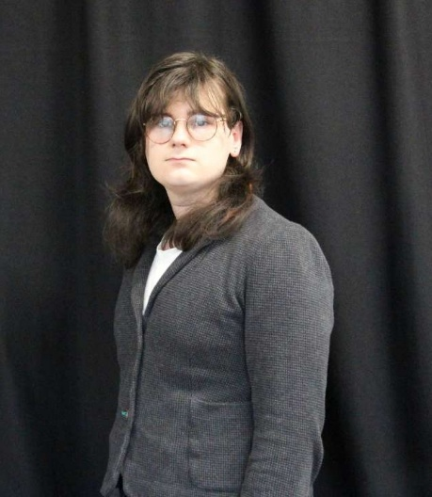

Remi Lovelady
Bencounsell14@gmail.com – (44) 07514 563493
Tenor

THEATRE
Ace Studios Showcase Willy Wonka/Dewey Finn Southport Little Theatre

Frankenstein the Musical. Alternate Henri/Monster/Ensemble Edge Hill University

Edge Hill University (Christmas Carol Concert). Chorus Edge Hill University

TRAINING
Vocal Training/Technique Carrie Simone 2024 - Current
Acting Edge Hill University 2024 - 2027
Vocal Training/Technique Edge Hill University 2024 - 2027
Dance Edge Hill University 2024 - 2027
Vocal Training/Technique Jacqui Lewis 2020 – 2024

SPECIAL SKILLS
Accents: British RP, Cockney, Standard American. Normal accent: Non-Specific British. Classically trained singer. Stage combat. Emotion through singing and acting. Improvisation. Experience being the subject of intimacy training.

ACADEMICS / COMMUNITY SERVICE
ACE Studio Performer

Edge Hill University BA(Hons) Musical Theatre 2024 - Current

LCMA- Grade 8 vocal performance | Distinction

